

Tower

Design Guidelines Document

Revision History

|  |  |  |  |  |
| --- | --- | --- | --- | --- |
| **No** | **Version** | **Date** | **Author** | **Sections Affected / Remarks** |
| 1 | 1.0 | 2/29/2016 | Anand V. | Initial Revision (pending form validation and displaying error messages) |
|  |  |  |  |  |
|  |  |  |  |  |
|  |  |  |  |  |

Table of Contents

**Page Layout** 4

Page Mechanics 4

Body 4

Content Area 4

Sub-Menu 5

Page Title 5

Vertical and Horizontal Scroll Bars 5

Grid Control 6

Grid Options 6

Footer Area 6

Colors Codes 7

**Usability and Formatting** 8

Readability 8

Visual Consistency 8

Fonts 8

Links 8

Buttons 8

Labels 9

Input Boxes 9

Date Fields 9

# **Page Layout**

**Built on common web frameworks and technologies:**

* AngularJS version 1.5.0
* Bootstrap
* jQuery
* CSS 3
* Font Awesome

# Page Mechanics

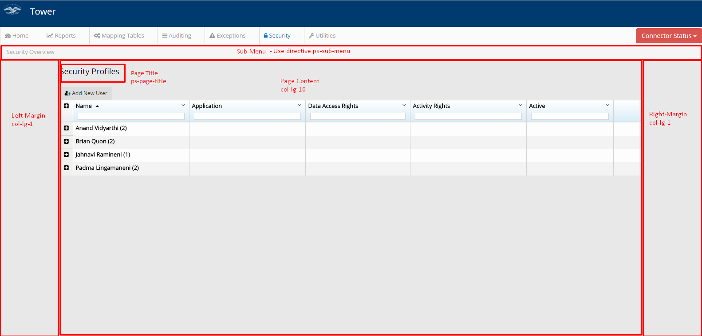

## Body

The body of the page is created as a <div>

CSS: ps-dashboard-header

## Content Area

The body area should contain built-in margin accommodations at the far left and right of the display area. The Left margin area can later be used if required for additional menu options.

## Sub-Menu

The sub-menu will be horizontal and will be displayed within the primary content area. There may be scenarios in which the sub-menu categories will require child navigation. The sub-menu items will be relative to the page, there could be one or more sub-menu items. These can be added to the pages under <ul> and <li> using ps-sub-menu and ps-sub-menu-item directives created.

For e.g.:

<ul class="breadcrumb">

<li class="subbreadcrumb">

<ps-sub-menu>

<ps-sub-menu-item label="Security Overview" route="securityhome">Security Overview</ps-sub-menu-item>

</ps-sub-menu>

</li>

</ul>

## Page Title

The information entered in the title field for each page should be concise, yet contain helpful relevant information. A unique name for each page is advisable.

CSS: ps-page-title

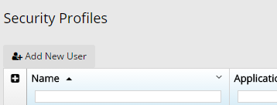

## Vertical and Horizontal Scroll Bars

All the pages should avoid horizontal scroll bars. Vertical scroll bars on the page is acceptable. Critical features such as login should not appear “Below the Fold”.

“Below the Fold” refers to that area at the bottom of the browser screen that limits what can be displayed to the user.

## Grid Control

All the pages will be using AngularJS ui-grid control.

### Grid Options

* Allow double click option to view/edit/delete
* Allow sorting of columns
* Allow filtering of selected columns (page specific)
* Allow export to PDF/CSV (page specific)
* Allow grouping of data in the rows (page specific)
* A button to “Add New..” above the grid

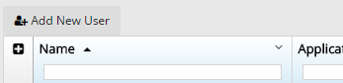

* 15 rows to be displayed by default

Pagination should be visible on both the top and the bottom of the grid. The grid height should dynamically adjust if the user selects to view more than 15 rows in a single page view.



The grid header CSS: grid-header

## Footer Area

The footer area will contain the First American Title link and the Copyright [current year]. For all instances the footer must appear beneath the primary application display area.

## Colors Codes

|  |  |  |
| --- | --- | --- |
| **Color** | **Color Codes** | **Purpose** |
|  | #000000 | Text color by default |
|  | #E8E8E8 | Page content, body |
|  | #013A6F | Header |
|  | #FBFBFB | Sub-menu background color |
|  | #B2AFAA | Sub-menu text color |
|  | #007ACC | Menu and sub-menu text color when active or when mouse hover |

# **Usability and Formatting**

## Readability

### Visual Consistency

* Place the same or similar elements (widgets, error messages, etc...) in a uniform location throughout the application.
* Be consistent in the use of colors, fonts and backgrounds as well as and the locations and size of labels, text and icons.
* Use consistent terms when referring to the same item in field names, error messages, help text, reports, etc. Example: User ID, user name.

## Fonts

##### Acceptable Font Families

* Open Sans
* Arial

##### Font Styling

* Ensure that the format of common items such as headings, subheadings, labels are consistent throughout the application.
* Use proper sentence casing, do not use all-caps fonts or text.

## Links

* All the links should preferably have a tooltip.
* The text color should change on mouse hover/focus.

## Buttons

* Ensure the button click behavior is consistent on all the pages.

|  |  |
| --- | --- |
| **Label** | **Definition** |
| Add | Should open a modal popup to allow the users to add a record for a particular entity. |
| Update/Edit | Should open a modal popup to allow the users to edit a record for a particular entity. |
| Delete | Should open a popup to ask user to confirm the delete action. |
| Continue or Next | Proceeds to the next step in a process or the next page. |
| Previous or Back | Returns to the last step in a process or the preceding page. |
| Submit | Should be used when the user is ready to commit the data for processing, this will pass data from the page to the database. |

## Labels

* All the labels in the forms should be left aligned.
* Capitalize the first characters.

For e.g. Lender Name

* Leave space between the label and the input field.

## Input Boxes

* Match the input box sizes throughout the form.

### Date Fields

* The calendar dates should be displayed in mm/dd/yyyy format.
* A date picker option should be available in case a date entry is required.
* Clearly indicate AM, PM